

Functional Requirements Document (FRD)
  - Customer Name – Job Number

Copyright© 2018, Oracle and/or its affiliates. All rights reserved.
Any reproduction or distribution of any part of this document without the prior written permission of Oracle + NetSuite is strictly prohibited.
The information included in this document is confidential and proprietary information of Oracle + NetSuite.
Version: March 3, 2022

Oracle + NetSuite
2955 Campus Drive, Suite 100
San Mateo, CA. 99403-2511

Project Information
Implementation Name
Customer Name (Number)
Job Name (Number)
Document Owner
Project Manager
Lead Developer

Document Version History
Rev | Date | Author(s) | Change Summary
1.0.1 | 7/24/2023 | Santiago Estellano | Second draft

Table of Contents
1 Business needs 4
1.1 Product Listing Pages: multiple add-to-cart functionality 4
1.2 Product Listing Pages: display stock available by location 4
1.3 Fields in Product Listing Pages 4
2 Acceptance criteria 4
3 Solution proposal 4
4 Prerequisites 4
5 Assumptions 4
6 Constraints and limitations 4
7 Risks 4

Business needs
Power Wholesale Management, Inc. (commercial name: Broadline Cable) is currently developing its SuiteCommerce web store, which sells a wide variety of audio, video, and electronic products. The client is looking to include additional functionality for Product Listing Pages (PLPs), so that clients can accurately identify products and available stock.

Stock Available by Location in Product Listing Pages
SuiteCommerce users must be able to easily identify the available stock for each location, so that they may place an order to be picked up at their most convenient location. (below add-to-cart button)

Fields in Product Listing Pages
SuiteCommerce users must be able to see each item’s SKU and Brand in the Product Listing Page, so that they may accurately find the product they are looking for.

Impacted Areas/Modules

Stock Available by Location in Product Listing Pages
Stock Available by Location of the item will be as well displayed for all users (logged in or not) below the add to cart button in the Product Listing Pages (PLP).

Fields in Product Listing Pages
The SKU, Brand and Short Description of the item will be displayed for all users (logged in or not) below the product name in the Product Listing Pages (PLP).

Acceptance criteria

Stock Available by Location in Product Listing Pages
- When navigating to a Product Listing Page, all stores are listed for each item and display available stock in each location

Fields in Product Listing Pages
- Product Listing Pages displays SKU and Brand fields as specified in the item record

Solution proposal

Stock Available by Location in Product Listing Pages

Fields in Product Listing Pages
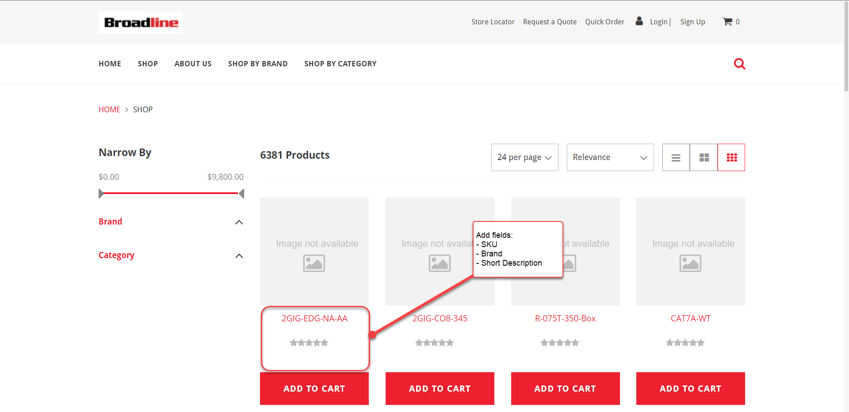

Prerequisites

Assumptions
- Client is responsible for updating stock availability information by location
- Content for Short Descriptions will be provided and set by the client

Constraints and limitations

Risks
- Adding custom fields and stock by location will affect Product Listing Pages’ look and feel, which may be different from out of box functionality
Oracle + NetSuite Professional Services and Customer are in agreement that the information documented above is accurate and representative of the customer’s business needs. This document will act as the basis for all subsequent implementation activities.
Document delivery date: MM/DD/YYYY

